ASSIGNMENT-2

21MAT204

MIS-3  
Professor-Dr. Soman/Dr.Neethu Mohan

1. Compute the value of Cos(pi/4) by taylor series expansion upto 10 terms. Use ‘For Loop’ in MATLAB.

Ans. We will use the general formulae of COSINE derived from taylor series and put that in a for loop as an iterative function that will give us iterations upto 10 terms.

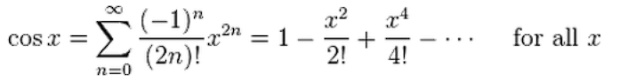

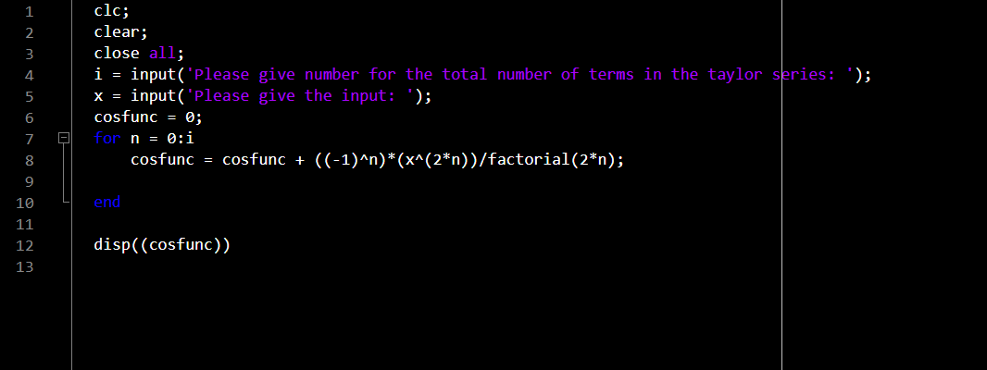

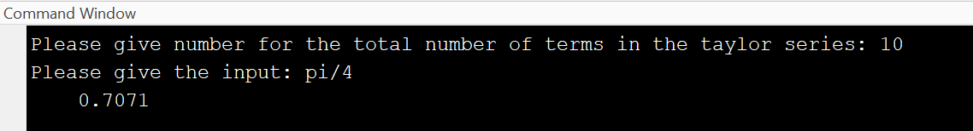Output:

2. Compute the value of Sin(pi/4) by taylor series expansion upto 10 terms. Use ‘WHILE Loop’ in MATLAB.

Ans. We will use the general formulae of SINE derived from taylor series and put that in a while loop(conditional loop) as an iterative function that will give us iterations upto 10 terms.

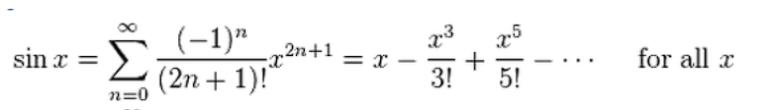

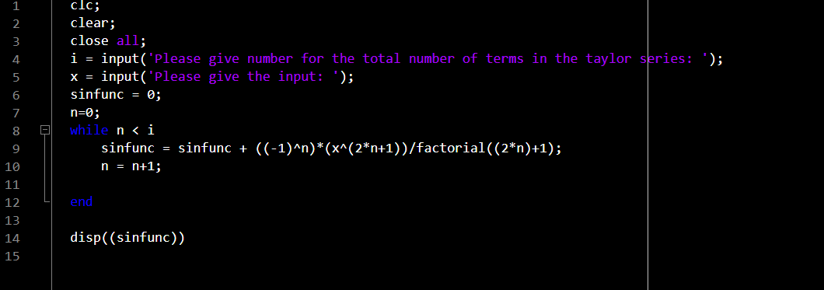

Output:

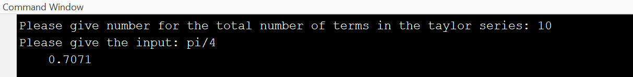

3. Compute the value of exp(2) by taylor series expansion upto 10 terms. Use ‘For Loop’ in MATLAB.

Ans. We will use the general formulae of EXPONENTIAL derived from taylor series and put that in a for loop as an iterative function that will give us iterations upto 10 terms.

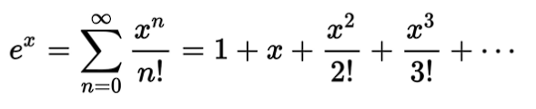

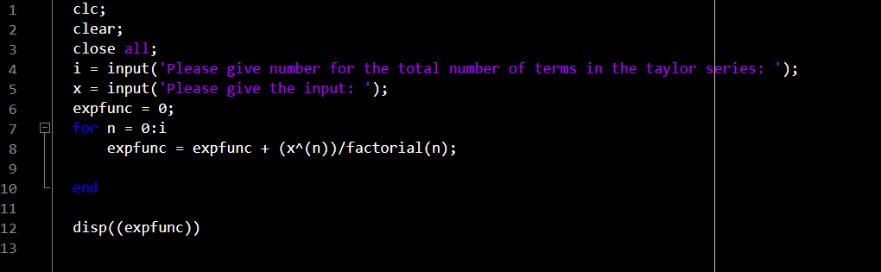

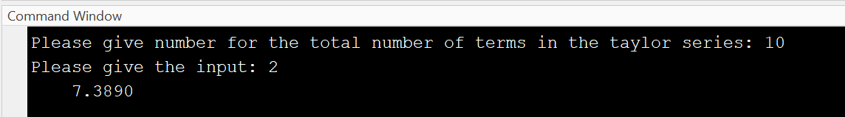Output:

4. Compute the value of exp(-2) by taylor series expansion upto 10 terms. Use ‘WHILE Loop’ in MATLAB.

Ans. We will use the general formulae of EXPONENTIAL derived from taylor series and put that in a while loop(conditional loop) as an iterative function that will give us iterations upto 10 terms.



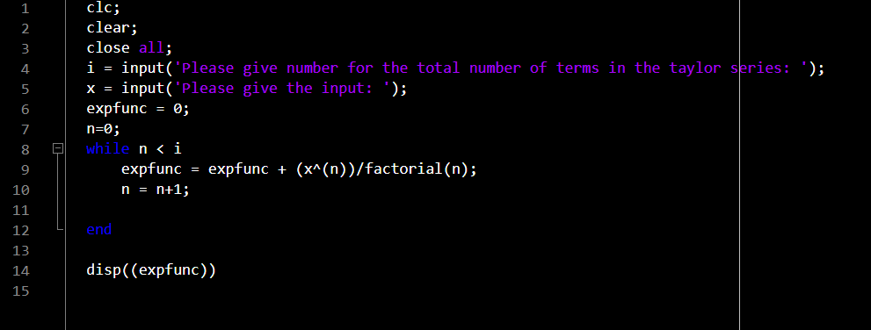

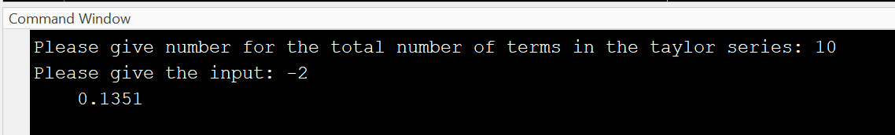Output:

5. Compute Cos(pi/4), Sin(pi/4), e2,e-2 by taylor series using 10 iterations each by writing a single formula in Microsoft excel cell and dragging it.

Ans.

Using a single formula from taylor series to get series for other functions is hectic task so we will instead go for formulae already derived for the functions and get the value of each function at a point x with fixed number of iterations.

Cos(pi/4)

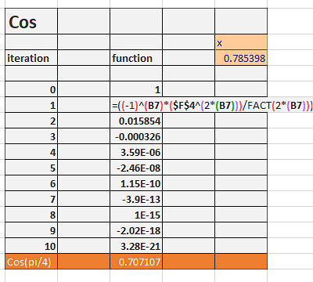

Sin(pi/4)

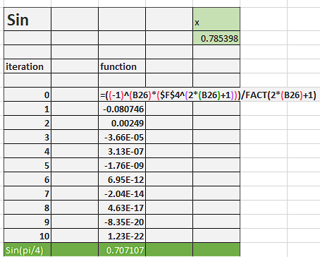

e2

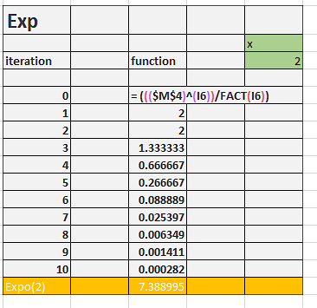

e-2

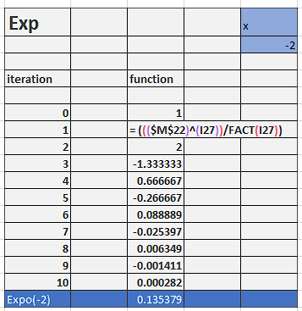

6. Find square root and cube root of 1000 using iterative formula also known as Newton-Raphson’s method.

Ans.

Newton Raphson Formula:

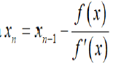

Firstly, we will choose appropriate function and then iterate it over and over to get the approximate value after some iterations.

In case of square root, the function can be  
f(x) = x2 – 1000  
f’(x) = 2x  
xo = 1

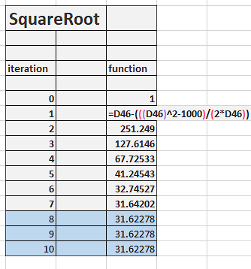

In case of cube root, the function can be  
f(x) = x3 – 1000  
f’(x) = 3x2  
xo = 1

